**Normalization:**

**Aisle Table functional dependencies:**



**Normalization Discussion:**

1. Candidate keys: aisle_id, aisle
2. The table is in BCNF as there are only 2 fields and both can act as super keys. So all functional dependencies have a super key on LHS

**Departments Table functional dependencies:**



**Normalization Discussion:**

1. Candidate keys: department_id, department
2. The table is in BCNF as there are only 2 fields and both can act as super keys. So, all functional dependencies have a super key on LHS

**Orders Table functional dependencies:**

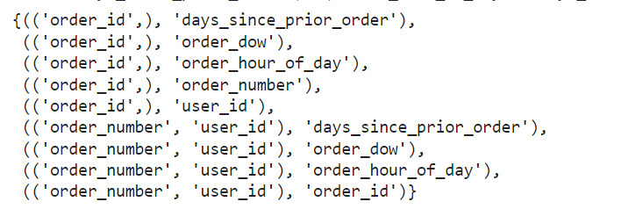

**Normalization Discussion:**

1. Candidate keys: order_id, (order_number, user_id)
2. The table is in BCNF form as all the functional dependencies found above have a super key in LHS.

**Products Table functional dependencies:**

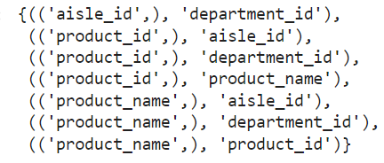

**Normalization Discussion:**

1. Candidate keys: product_id, product_name
2. The dependency “aisle_id -> department_id” does not have a super key on LHS and neither it has a prime attribute on RHS hence it is not in 3rd Normal Form.
3. The table is in 2nd Normal Form as the functional dependency “aisle_id -> department_id” is not partial dependency and all other functional dependencies have a super key on LHS
4. To convert this table into 3NF, we would have to create a separate table for aisles_id and department_id

**Users Table functional dependencies:**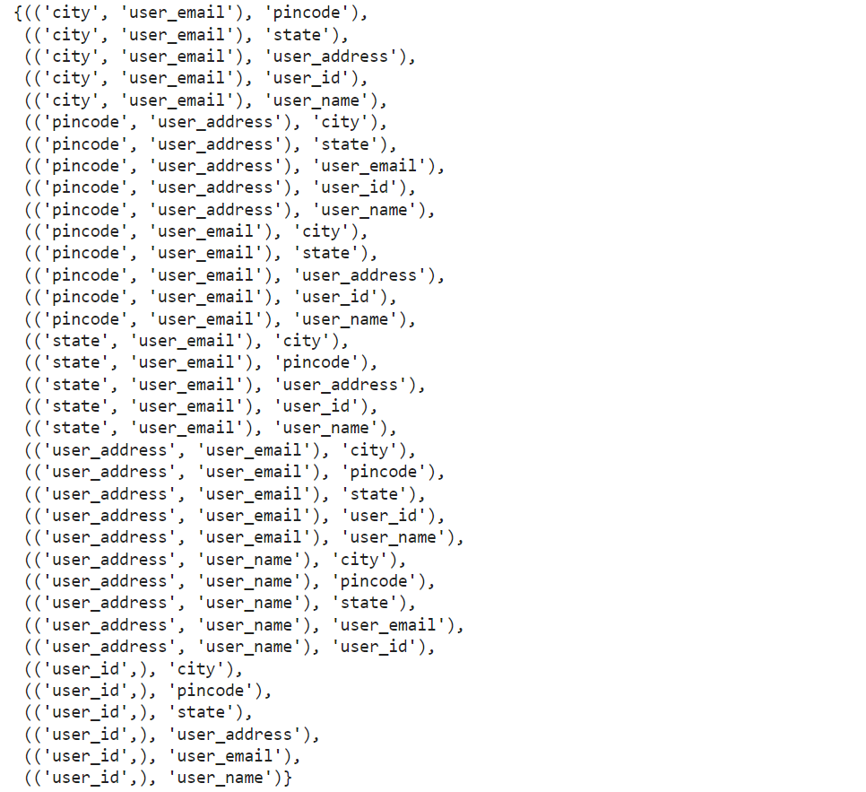

**Order Products Table functional dependencies:**

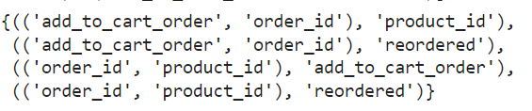

**Normalization Discussion:**

1. Candidate keys: (add_to_cart_order, order_id), (order_id, product_id)
2. The table is in BCNF form as all the LHS values in the functional dependencies are composite fields which are candidate keys.